Enterprise Architecture and Design

Service Lifecycle

Version 1.0

Document Modification Control:
Date | Author | Role | Version | Comments
10/06/2011 | Paul Ballard | SOA Domain Architect | 0.1 | Initial draft
11/07/2011 | Paul Ballard | SOA Domain Architect | 1.0 | Updated following peer review comments

Review:
Date | Reviewer | Role | Version | Comments
01/07/2011 | Catherine Ramsay | LP&I Service Architect | 0.1
05/07/2011 | Carl Dunk | EAD Enterprise Architect | 0.1

Document Approval:
Date | Name | Role | Version | Comments

Distribution List:
Date | Name | Role | Version | Comments
Contents Page

1 Service Architecture Context 5
2 Background 5
3 The Service Lifecycle 6
3.1 State Diagram 6
3.2 Alignment with SDLC 7
3.3 The 'Identified' Lifecycle state 8
3.3.1 Description 8
3.3.2 Transition conditions 8
3.3.3 Required Artefacts 8
3.3.4 SDLC Alignment 8
3.4 The 'Planned' Lifecycle state 9
3.4.1 Description 9
3.4.2 Transition conditions 9
3.4.3 Required Artefacts 9
3.4.4 SDLC Alignment 9
3.5 The 'Specified' Lifecycle state 9
3.5.1 Description 10
3.5.2 Transition conditions 10
3.5.3 Required Artefacts 10
3.5.4 SDLC Alignment 10
3.6 The 'Built' Lifecycle state 10
3.6.1 Description 11
3.6.2 Transition conditions 11
3.6.3 Required Artefacts 11
3.6.4 SDLC Alignment 11
3.7 The 'Certified' Lifecycle state 11
3.7.1 Description 11
3.7.2 Transition conditions 11
3.7.3 Required Artefacts 12
3.7.4 SDLC Alignment 12
3.8 The 'Operational' Lifestyle state 12
3.8.1 Description 12
3.8.2 Transition conditions 12
3.8.3 Required Artefacts 12
3.8.4 SDLC Alignment 12
3.9 The 'Sunset' Lifecycle state 13
3.9.1 Description 13
3.9.2 Transition conditions 13
3.9.3 Required Artefacts 13
3.9.4 SDLC Alignment 13
3.10 The 'Retired' Lifecycle state 14
3.10.1 Description 14
3.10.2 Transition conditions 14
3.10.3 Required Artefacts 14
3.10.4 SDLC Alignment 14
4 Document References 14

Service Architecture Context
The Service Lifecycle defines all the states which a service can have and is a key enabler in performing SOA Governance; the completed lifecycle model provides a potent tool for eliciting the more detailed policies for governing the efficient development and usage of software services.
The Service Lifecycle is closely aligned with the Lloyds Banking Group SDLC. This document articulates the lifecycle states, conditions for transitioning to the next lifecycle state, the required artefacts (with quality and completeness consideration) at each lifecycle state and the alignment to the SDLC.
At all times, every service must have a defined lifecycle state; this is a SOA principle for LBG. This is particularly important for Service Identification such that projects can understand what services the business should be building and where the service is in terms of the lifecycle (thus informing what effort the project requires to make to use of the identified capability).

Background
The purpose of a well defined, documented Service Lifecycle is to:
- Provide control over our service assets.
- Enable clearly defined and visible SOA governance; implemented via controlling the transition between states.
- To assist and improve the quality in the discovery and identification of services; a project will have a clear, consistent and current view of the state of all services within the LBG Service Portfolio Plan thus improving reuse and removing duplication.
- To improve control over decommissioning or system rationalisation activities; it is easier to understand and see redundant capability.
This document captures the Service Lifecycle for LBG at a logical level. Further documentation will describe how this is used within the Insurance SOA Governance framework and how tooling will support the LBG Service Lifecycle.

The Service Lifecycle

State Diagram
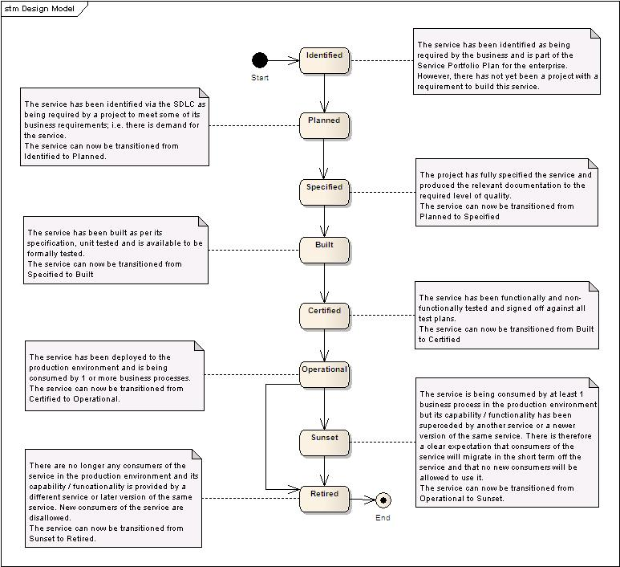

Alignment with SDLC
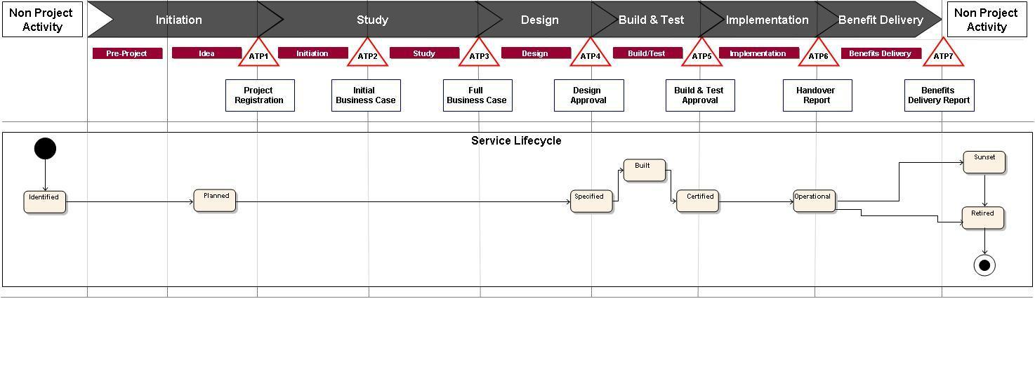

The 'Identified' Lifecycle state
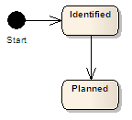

Description
A service at the 'Identified' Lifecycle state has been identified as being required by the business and is part of the Core Service Map and Service Portfolio Plan (SPP) for LBG. The inclusion of the service within these artefacts has been formally approved and there is therefore an intention at some point to provision this service.
The SPP should indicate where the demand for the service originated from, time scales and potential consumers.
It could also be that a new version of an existing service within the SPP has been identified as required to support a new business capability, process or requirement.
The service will be identified in the LBG Core Service map.
There is no planned project or programme provisioning this service; it purely exists in the SPP.

Transition conditions
For a service to be in the Identified state, it has to satisfy the following criteria:
- It has been has been approved as being part of the SPP or there is a requirement for a new version of an existing service in the SPP (required to support a new business requirement).
- It exists only in the SPP, there has been to date no requirement to provision the service.

Required Artefacts
None – it must however be formally identified within the approved SPP.

SDLC Alignment
The identification of a service within the SPP is outside of SDLC activity.
Where a project has a new business requirement which will cause a new version of an existing

The 'Planned' Lifecycle state
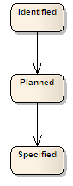

Description
At the planned Lifecycle state, SDLC process has identified that a service at the Identified state is required to meet a project's functional or non-functional requirement. So there is now a change programme which will be implementing the service to a clear timeline.
Note: Once the Planned lifecycle state has been achieved, the service will intuitively move into the 'Being Specified' state although this state is not a formal part of the Service Lifecycle.

Transition conditions
Once a project has performed the Service Identification process to match its functional and non-functional requirements to services within the SPP, it will have identified its scope of change required to meet its requirements. Once the version of the service has subsequently been included in the projects formal, approved design documentation it can be transitioned to Planned.

Required Artefacts
None – it must however be formally identified within the approved SPP and a live project must have identified it is being within its scope to meet a functional or non-functional requirement.

SDLC Alignment
The Planned state is aligned to the Idea state within the SDLC. It is at this point in the process that service identification is performed to match the requirements a project has to the services within the SPP. At this point, the project will have identified the service as being within its scope and will have documented this in the relevant design documentation; thus formally moving the service to the 'Planned' state.

The 'Specified' Lifecycle state
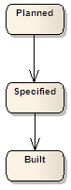

Description
At the specified lifestyle state, a service will have a completed rich Service Specification, a completed set of Service Usage Contracts and a completed Automation Unit specification. The 3 or more specification deliverables will have been formally approved by the SOA governance process.
Note: Once the Specified lifecycle state has been achieved, the service will intuitively move into the 'In Build' state although this state is not a formal part of the Service Lifecycle.

Transition conditions
A Planned Service can only transitioned to the Specified state if all the following conditions are met:
- A rich Service Specification for the service which has been quality assessed by a relevant SOA governance body.
- Service Usage Contracts for the planned Consumer / Provider interactions which have been quality assessed by a relevant SOA governance body.
- A physical software specification for the service which has been quality assessed by a relevant SOA governance body.

Required Artefacts
- A rich Service Specification for the service which has been quality assessed by a relevant SOA governance body
- Service Usage Contracts for the planned Consumer / Provider interactions which have been quality assessed by a relevant SOA governance body.
- A physical software specification for the service which has been quality assessed by a relevant SOA governance body.

SDLC Alignment
The transition to the Specified state must align to the ATP4 (design approval) point within the SDLC. At this point, the design of the service is completed and has been formally approved by the relevant governance bodies.
To get to the fully specified state, an evolving service design would have commenced from ATP1 in line with the defined SDLC process.

The 'Built' Lifecycle state
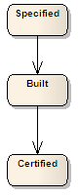

Description
At the Built lifecycle state, the service's automation unit has been coded and formally unit tested. The software aligns with the formally approved rich Service Specification, Service Usage Contracts and Automation Unit specification.
The service is now ready to be tested.
Note: Once the Built lifecycle state has been achieved, the service will intuitively move into the 'Being Certified' state although this state is not a formal part of the Service Lifecycle.

Transition conditions
A Specified Service can only transitioned to the Built state if all the following conditions are met:
- Its Automation unit has been fully coded and deployed to a suitable test environment.
- There is a formally signed off unit test report for the Automation Unit.

Required Artefacts
- A coded, deployed (in a test region) and unit-tested automation unit for the service.
- A formally signed off unit-test report for the automation unit.

SDLC Alignment
The transition to the Built state from the Specified state is aligned to the Build / Test SDLC stage between ATP4 and ATP5. At some point in this part of the process, the service will transition to the Built state subject to the transition conditions being met.

The 'Certified' Lifecycle state
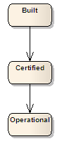

Description
At the Certified lifecycle state, the service's automation unit has been formally tested and passed the relevant quality standards for meeting the projects functional and non-functional requirements.
The service is now ready to be deployment to the operational environment.

Transition conditions
A Built Service can only be transitioned to the Certified state if all the following conditions are met:
- It has been formally signed off against a functional test plan.
- It has been formally signed off against a non-functional test plan.
- It has been proven to be fit for purpose for deployment into the operational environment.

Required Artefacts
- A functional test plan for the service which has been quality assessed by a relevant SOA governance body.
- A formally signed off non-functional test plan for the service.

SDLC Alignment
The transition to the Certified state from the Built state is aligned to ATP5 at the end of the Build / Test SDLC stage. It should not be possible to achieve ATP5 without all the services in scope for the project being transitioned to the certified state.

The 'Operational' Lifestyle state
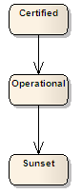

Description
At the Operational lifecycle state, the service's automation unit has been deployed into the operational environment by the project and the service is being consumed by at least one business process / event. Its behaviour and usage is monitored and alerts acted upon.

Transition conditions
A Certified Service can only be transitioned to the Operational state if all the following conditions are met:
- It has been formally deployed into the operational environment and is being consumed by at least one business process or event.

Required Artefacts
None

SDLC Alignment
The transition to the Operational state from the Certified state is aligned to ATP6 at the end of the Implementation SDLC stage. It should not be possible to achieve ATP6 without all the services in scope for the project being transitioned to the Operational state.

The 'Sunset' Lifecycle state
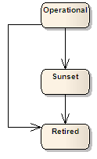

Description
At the Sunset lifecycle state, the service has been identified as having been replaced in the SPP by newer releases of the service, or has been replaced by a different combination of services. It is therefore no longer available for reuse but will support existing consumers until such time as they are migrated away.
Note: It is permissible to transition directly from the Operational state to the Retired state if there is only 1 consumer of the service, the consumer is migrated to a newer service in the Operational state and the SPP identifies that the newer service replaces the functionality of the now unconsumed service.

Transition conditions
An Operational Service can only be transitioned to the Sunset state if all the following conditions are met:
- There is a newer release of the service in the Operational state which supports all the functionality of the current version.
- There is a different service which is in the operational state, meets the functional and non-functional requirements of the service and has been identified in the SPP as being the replacement for the service.

Required Artefacts
None

SDLC Alignment
The transition to the Sunset state from the Operational state is not aligned to an SDLC stage but would be triggered by a new release of the service or a suitable replacement service being transitioned to the Operational state.

The 'Retired' Lifecycle state
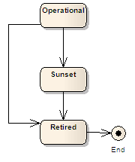

Description
At the Retired state, the service has become obsolete and is no longer consumed by any software. The last consumer of the service has migrated to a different service or no longer requires functionality provided by the service. It will not be possible to consume the service in the operational environment and all relevant artefacts have been archived for possible future reference.

Transition conditions
An Operational or Sunset Service can only be transitioned to the Retired state if all the following conditions are met:
- There are no longer any consumers of the service in the operational environment.
- A replacement service has been identified in the SPP and it is at the Operational state.

Required Artefacts
None

SDLC Alignment
The transition to the Retired state from the Operational or Sunset state is not aligned to an SDLC stage but would be triggered by the last consumer of the service being migrated away and by the identification of a replacement service in the Operational state in the SPP.

